**Machine Learning Project**

**Final Project Report**

Harin Avvari, Kevin Grewal, Tino Jimenez, Jonathan Nguyen, Alan Viollier, Angela Yang

December 8th, 2022

CS 160 Section 4

Team #5: ML Group

**Machine Learning**

Discord Link:

<https://discord.gg/9stZaNub4p>

**Contents**

Contributions

Website and Password Information

Task Accomplished Checklist

Implementation of Core Features

Four Features

Emerging Technology used for the project

Lack of expertise that could have helped you in this project

New skill learned and applied to this project

Need for continuous professional development

Website Implementation and Public Web Hosting Preparation Process

How you install/configure/enable open-source modules

Website Testing on Selenium

Testing Platform Information

Typical Flow of Website with Narrated Snapshots

Homepage

Introduction to Machine Learning Page

Machine Learning Algorithms Page

Machine Learning Interview Preparation

Machine Learning News and Trends Page

Version Control on Drupal

Final Specs, Use Cases, Use Case Diagram

Feature #1 Intro to Machine Learning for Beginners (Core Requirement c2, c5)

Introduction to Machine Learning Page

How it will be useful to users

Why this is Innovative

URL References

Feature #2 Machine Learning algorithms with coding examples/practices (Core Requirement c1-c5)

ML Algorithms Page(Intro page with subpages for each algorithm)

How it will be useful to users

Why this is Innovative

URL References

Feature #3 Machine Learning Interview Preparation (Core Requirements C1, C3, C5)

Machine Learning Interview Prep Page

How it will be useful to users

Why this is Innovative

URL References

Feature #4 Machine Learning Trends and News (Core Requirement c1 & c3-c5)

News And Trending Page

How it will be useful to users

Why this is Innovative

URL References

Use Cases

Use Case Diagram

# **Contributions**

| Feature/Task | Description | Contributors |
| --- | --- | --- |
| Webpage creation for Introduction to ML | Introduction to all things Machine Learning. Includes the what, why, basic types of machine learning, applications, and prerequisites. | Tino, Alan |
| Webpage creation for ML Coding Exercises | Includes different types of algorithms with links to each specific algorithm. Also provides coding walkthroughs. | Tino, Harin |
| Webpage creation for Interview Preparation | A good resource to help users learn specific interview topics. Additional, external resources will be provided to assist the user with interview preparation. | Kevin, Angela |
| Webpage creation for News and Trends | The user can look up current news and trends regarding machine learning. Helps the user keep up to date with popular topics. | Tino, Jonathan, Angela |
| Work on hosting webpages in remote server | Uploaded Drupal files to FTP server  Exported database to the cloud database server | Tino |
| Powerpoint Preparation | Prepared Slides for presentation | Harin, Kevin, Tino, Jonathan, Alan, Angela |
| Final Report | Worked on final report | Harin, Kevin, Tino, Jonathan, Alan, Angela |
| Powerpoint Presentation | Presented Powerpoint during class | Harin, Kevin, Tino, Jonathan, Alan, Angela |

# **Website and Password Information**

**Website Links**

Homepage: <https://chris-tseng.com/classes/cs160/sec4/team5/Tino>

Login Page:<https://chris-tseng.com/classes/cs160/sec4/team5/Tino/user/login>

**Database and Server Information**

Database Username: christse_sec4team5

Database Password: DBGr0upF1v3

Server Username: sec4team5@chris-tseng.com

Server Password: FTPGr0upF1v3

**Account Information**

Admin Username: admin

Admin Password: @dm1n

Non-Admin Username #1: Angela

Non-Admin Password #1:@ng3l@

Non-Admin Username #2: Kevin

Non-Admin Password #2: K3v1n

# **Task Accomplished Checklist**

|  | 1. **Implementation of core features** |
| --- | --- |
| X | A.1 At Least 4 of Your Proposed Features Implemented |
| X | A.2 Emerging technology used for your project |
| X | A.3 Lack of expertise that could have helped you in this project |
| X | A.4 New skill learn and applied to this project |
| X | A.5 Need for continuous professional development |
|  | 1. **Server-side script hosting** |
| X | B.1 Provide one admin account and 1 non-administrator accounts |
| X | B.2 Upload your web script to your public website |
| X | B.3 Share the public web link on the report |
|  | 1. **Software requirement, development** |
| X | C.1 Design Document |
| X | C.2 Validated and modified use cases for each implemented feature |
| X | C.3 User case diagrams |
| X | C.4 Agile design description |
|  | 1. **Software versioning** |
| X | D.1 Show snapshots of one complete checkin and check-out of version control process |
| X | D.2 Add the instructor and the TA to your Github repository (or similar) |
|  | 1. **Testing** |
| X | E.1 Use Selenium IDE on Firefox or similar to record one test suite on one complete workflow (including login) in your website |
| X | E.2 Summarize in a table the testing against various popular browser and versions |
|  | 1. **Compose technical reports and participate in technical discussion** |
| X | F.1 Provide a technical following the report template |
| X | F.2 Participate and collaborate on Discord |
|  | 1. **Peer evaluation** |
| X | G.1 Upload confidential evaluation |
| X | G.2 Provide Web-Based Peer Evaluation |

# **Implementation of Core Features**

## **Four Features**

The four features we have implemented for our website are:

1. Introduction to Machine Learning Page
2. Machine Learning Coding Exercises Page
3. Machine Learning Interview Preparation Page
4. Machine Learning News and trends Page

## **Emerging Technology used for the project**

**Harin**

Drupal, XAMPP, LucidChart, and Figma were the new technologies that I had used in this project. Lucid chart helped us make the flowchart and the use case diagram, and was very intuitive to learn. XAMPP allowed us to host a web server. A bit of HTML as well when working on the pages. Figma was used initially when designing what our site would look like.

**Kevin**

Drupal and XAMPP (Apache Server) were technologies that I used for this project. I used XAMPP to build a local web server on my computer to host the website that I created using Drupal. Drupal is a content management system which makes creating and managing websites easy even for people who do not know how to code. It has a drag and drop interface, allowing creators to visualize their website better. That said, there were a lot of features in Drupal that took time to get used to like the Themes, Content Structure and Modules.

**Tino**

Drupal, Selenium, HTML, Apache server, MySQL, LucidChart. LucidChart is an open source diagram creation software. It was used to create the sitemap flowchart and our use case diagrams. MySQL was used as the database backend and is what contains the pages of the site itself. The Apache server was used to host the website locally and is what was first used to host the initial version of the website before transferring the site to the Professor’s host server. HTML was used to create some of the content on various web pages. Selenium was used to test the website and ensure the website was working as designed. Drupal was used to create the infrastructure of the website, including managing the themes of the website, adding pages and creating users. It also acted as our revision control system. With the built-in revision creation and the ability to revert to previous versions, it suited our needs.

**Jonathan**

Drupal, XAMPP, LucidChart, and Selenium are the emerging technologies that I used for this project. Drupal, a PHP-based management system, was used to create, manage, and modify web pages on our website. Although I am familiar with HTML and CSS, I wasn’t very familiar with Drupal and its various features. XAMPP allowed me to host a local web server, which was necessary for setting up Drupal and getting familiar with how to use it. LucidChart is a web app that specializes in drawing diagrams, which was used in order to draw various diagrams in our milestone documents. Finally, Selenium is a testing tool for browsers to test if scripts are working properly.

**Alan**

The emerging technologies I used for this project are mainly XAMPP, Drupal, LucidChart, and Selenium. XAMPP is a web server solution stack package that allowed me to host a web server within my own computer for me to use. This made it so I could work on practicing my HTML and Drupal skills. Drupal is a web content management system that made it much easier and quicker to create and structure a fully functional website with many features. LucidChart is a web-based diagramming application that allows all of us to collaborate on flowcharts and use case diagrams with ease. Finally, I used Selenium which is software that allowed me to test our website thoroughly. All in all, there was a lot of new technology that I used in this class that I think was very useful in keeping us efficient.

**Angela**

Some technologies that I used were Drupal, XAMPP, and CyberDuck. I used Drupal along with HTML, CSS to create a website quickly. Creating a page was simple and did not require coding to get a basic page down. I used HTML and CSS to add more detail to the page. I used CyberDuck to move some Drupal files onto the FTP server. XAMPP allowed me to host a server and test Drupal locally.

## **Lack of expertise that could have helped you in this project**

**Harin**

I didn't have any experience with Drupal or HTML. Having even a little knowledge coming into this project would have helped in adding of neat features to the website instead of just the text blocks I put up. Didn’t have too much experience with git and github, but we didn’t even need it as drupal had built in version control.

**Kevin**

Understanding of FTP server-client combined with Drupal. The setup was a learning curve but I also understood how Drupal works and how to use it to build the website we envisioned.

**Tino**

My lack of familiarity with Drupal was really a hindrance. Not understanding how Drupal worked and how to use any of its features created a steep learning curve. This lack of foreknowledge actually created an issue for later in the project. Instead of using git and github to do version control and doing the website locally, we immediately transferred the site to the public hosting server. This didn’t allow us to install open source, third party software on the site.

Jonathan

Not being too familiar with Drupal limited my contribution to website development. If I had been more familiar with Drupal, then perhaps I would be able to do more on the feature I was assigned. Although I have heard of Git, I have little experience with it. Git would’ve helped with version control, which is also applicable to many other projects out there. Fortunately, Drupal also has built in version control that isn’t Git.

**Alan**

I don’t have much experience with HTML, website building, Git, or databases. Unluckily, these are all the main aspects of this project. Although not all used, having more experience with these would’ve made the project easier for me to understand and work on more efficiently. I could’ve helped Tino upload the website, but I simply didn’t understand how. With all this, throughout the project, I could still get a basic grasp of necessary aspects and put my fair share of work in to help my group. Drupal was also confusing to use at first, and I’m still not sure I fully understand it. All in all, in most aspects of this project, I had little to no experience, and I was quickly overwhelmed by having to learn and utilize them all.

**Angela**

There’s a lot to learn about Drupal- it has a high learning curve. There was a lot of new content to learn, and a lot of the information about Drupal was outdated or hard to understand. The lack of flexibility in designing the website was hard to adjust to. We were also unaware that we were able to collaborate together on the Drupal site, so we spent some time figuring out how to use Drupal with Github. I am familiar with HTML and CSS and was glad to see that those skills could be used in Drupal. I was able to change the layout and colors of the page using CSS.

**List to describe this for all members of your team**

* Website Building
* Databases (FTP server-client)
* Drupal
* Github

## **New skill learned and applied to this project**

**Harin**

Learning how to make use case diagrams and flowcharts was something I learned. We didnt need to code anything but getting used to drupal and collaborating as a team was definitely something I took away from this. The whole iterative cycle of creating something getting feedback and making improvements was also new to me.

**Kevin**

I learned how to form sequence and user diagrams based on a website’s user interface and user actions. I also better learned how to work alongside a group of people in sprints efficiently and effectively.

**Tino**

For this project, I learned how to create use cases and use case diagrams, as well as sequence diagrams. I learned how to use Drupal to create webpages and to do site administration. Also, I learned how to evaluate other teams’ work and find flaws in designs and the differences between those designs and actual implementation.

**Jonathan**

There were quite a few skills I learned and was able to apply to this project. One of the more important skills I was able to apply is teamwork, especially when working with agile and sprints. While I have worked with teams before, the agile process is quick and effective, keeping the team in communication and addressing any concerns anyone may have. I also learned how to create and host a website on a server, which may come in handy if I am required to.

**Alan**

Nearly every aspect of this project was a learning experience for me. Drupal is now a skill I have and can apply. I could use Drupal in the future to create my own website if I wanted to. I can also use the website-building skills I learned through this project with Drupal. Finally, working on such a large project with so many teammates, so much communication, lots of iterations, and plenty of external feedback has made me truly understand what working with a group is. Good communication and clear specifications go a long way to making a project successful. I feel like I am better prepared to work efficiently in a tech company with a group of people.

**Angela**

I learned how to use Drupal, which helped streamline our website creation. We didn’t really need to code anything to have a website up and running. I also learned how to create use case diagrams which helped us plan out the flow of the website.

## **Need for continuous professional development**

**Harin**

In our field absolutely. Technology has advanced so much and will continue to do so leaving so many old practices behind. Whether it be for the sake of making money or learning concepts, we need to adapt and continue to better ourselves in order to accomplish anything in this field. Take our example for this project; Just a few years ago we would have needed to have so much knowledge to make this simple website: databases, git, html,css. All we needed now realistically was setting up drupal. Staying on your toes and learning new things is crucial.

**Kevin**

Yes, I believe there is always a need for continuous professional development. There are constantly new technologies to pick up on, on top of the endless industries and specializations within software that require knowledge of different concepts and tools. After this project, I would like to continue bettering my skills in web development and server/client architecture. In terms of this project, I believe that we were able to become more comfortable with Drupal the more we used it, and we could definitely improve our website.

**Tino**

If you intend to have a long career in technology, continuous improvement is absolutely essential. With the speed of technological innovation, the ability to learn new technologies and the desire to do so, will be necessary. Without that desire and ability, your complacence will lead you to become obsolete in a constantly changing technological world. That obsolescence could lead to unemployment, career stagnation and/or low wages.

**Jonathan**

I think that continuous professional development is absolutely necessary. Technology is quickly growing and old technologies are being replaced with newer ones, such as VHS tapes and floppy disks. As technology evolves, employers are probably looking for potential employees with knowledge about current and future technology.

**Alan**

I think there will always be a need for continuous professional development in a field like computer science. Technology and software are always evolving, and I must develop continuously if I want to stay on top of it all. After this semester, I plan to learn more about full-stack development and learn all the skills and tools I need to be able to build a competitive website. In this day and age, having those skills will carry me a long way, and I can see that better after doing this project. There will never be a shortage of people and companies wanting an attractive new website.

**Angela**

I believe that we could continuously develop our website. We were overly ambitious in creating the specs for the website, and in the end, we had to scale back or remove some features. Now that we are more familiar with Drupal, I believe that we can expand our website to include more features. Technology is constantly changing and soon some features on Drupal will become deprecated. Software has to be constantly updated in order to stay relevant.

# **Website Implementation and Public Web Hosting Preparation Process**

**Website Implementation**

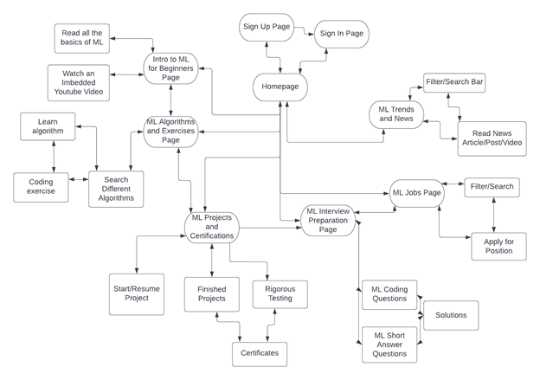

**Public Web Hosting Preparation Process**

The settings.php file in Drupal was configured so that Drupal would have the database information. The local drupal files were uploaded to the FTP server, and the website database was exported to the database cloud server. With these three tasks completed, the website is fully online and is visible to anyone on the web.

**Show its main components and how they rendered your dynamic website (illustrate with a diagram)**

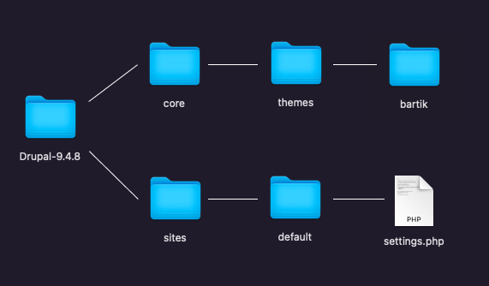

We used the default Bartik 9.4.8 theme for our website. The theme gave us a basic layout and color scheme to design our website on. Settings.php contains important information required by Drupal to run. It allows Drupal to connect the code to the database and configure other features about our website. We needed to configure our settings.php file to add information about our database, such as the name of the database, username and password for the database.

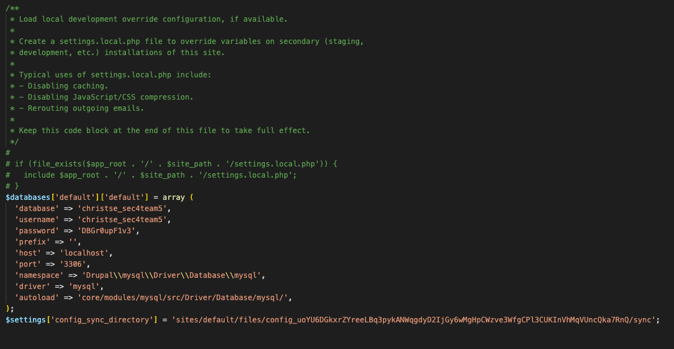

*Settings.php file*

## **How you install/configure/enable open-source modules**

*This project did not use any open-source modules. However, composer can be used to install new modules onto personal computers. Modules must be downloaded and installed into a local drupal directory, then enabled. Afterwards, the drupal files and database should be uploaded onto a remote hosting server. All of this must be done before uploading the files to a remote hosting server.*

# **Website Testing on Selenium**

*Selenium IDE is a tool that tests browsers with an automatic process. Selenium allows the tester to record steps in a test and save it. The saved test can be replayed on other browsers, automatically allowing the tester to efficiently test the steps taken on other browsers and operating systems.*

*After installing Selenium IDE from* [*https://www.selenium.dev/selenium-ide/*](https://www.selenium.dev/selenium-ide/) *on the correct browser, tests are now able to be recorded and played back. To start recording a new test, Selenium will prompt to either create a new project or test. If creating a new project, simply follow the steps prompted by Selenium. Afterwards, a new test can be conducted by hitting the ‘+’ in the top left corner of the Selenium window. To begin recording, click on the record button on the top right corner and enter the URL of the site to test.*

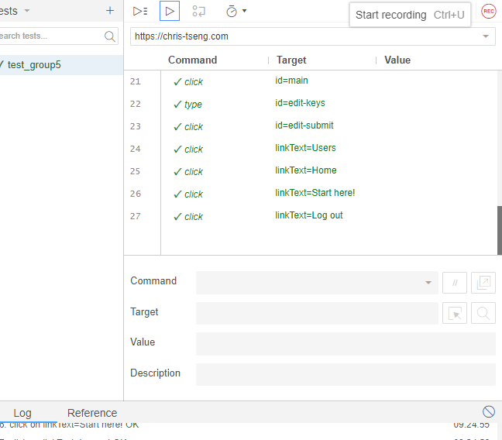

*(Layout of Selenium IDE UI)*

*During the recording process, the tester is free to do anything they want on the site. Users can click on various modules, navigate to different pages, even log in or log out of an account. Once recording is complete, return to the Selenium IDE window and hit stop recording.*

*To run a test, simply click on either the play current test or run all tests. Selenium should now open up the website for the test and run through everything done in that recording at a rapid pace.*

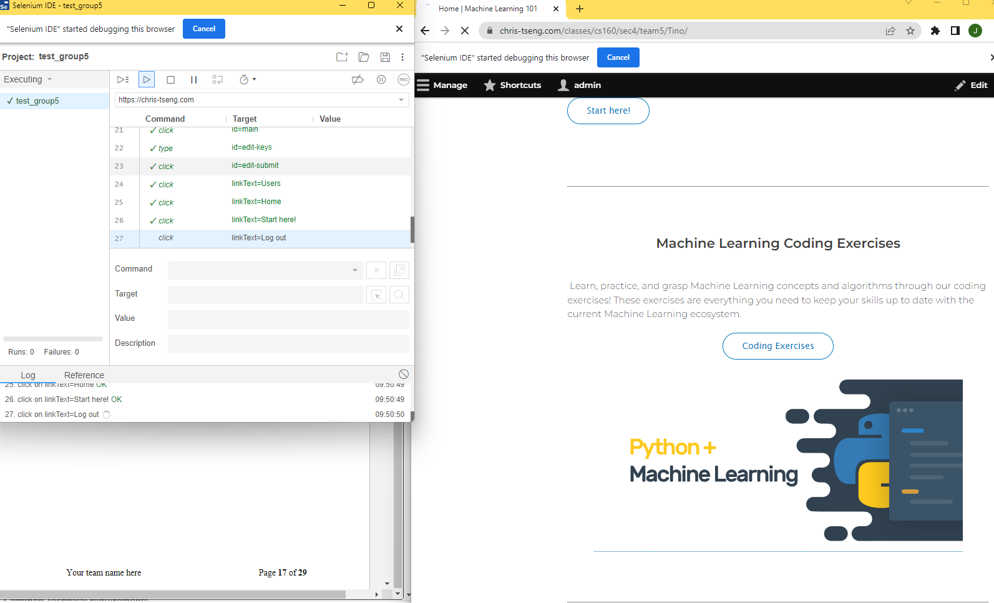

*(Example of a Selenium test in progress)*

*Once the test is finished, the IDE will return a success or an error along with a message about what caused the error. Below are the results of various tests on our group project.*

*Windows 10, Google Chrome Test*

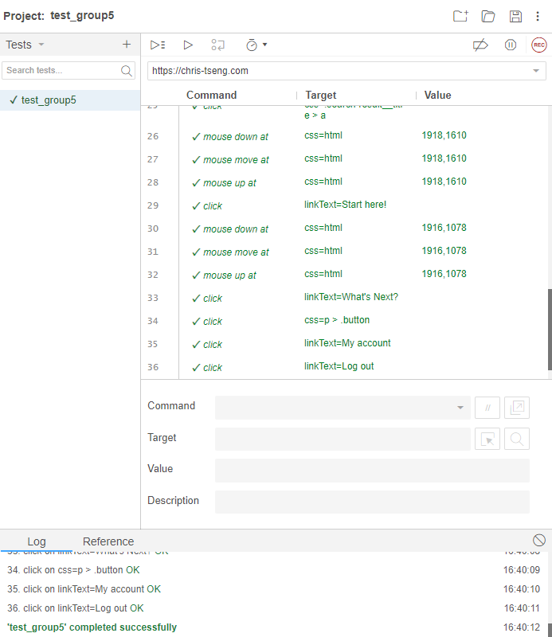

*Windows 10, Mozilla Firefox Test  
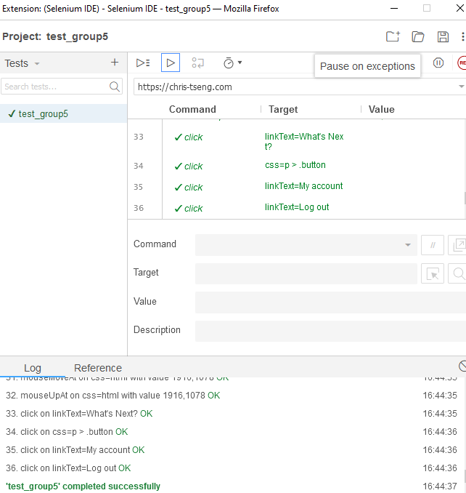*

*Windows 10, Internet Explorer 8 Test*

*This test cannot be conducted because Selenium is not supported by Internet Explorer 8*

*Windows 11, Google Chrome Test*

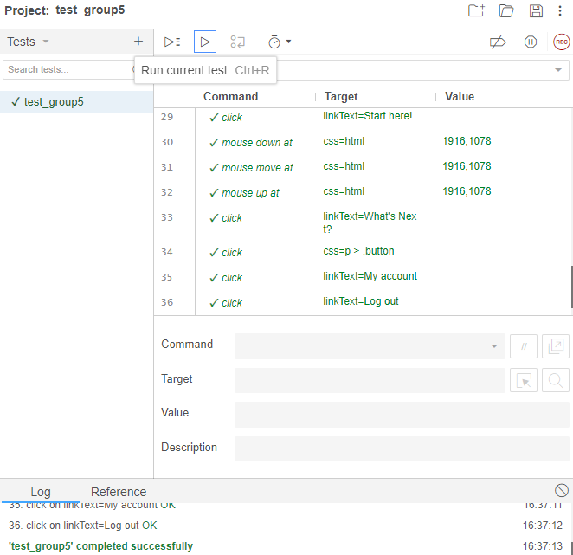

*Windows 11, Mozilla Firefox Test*

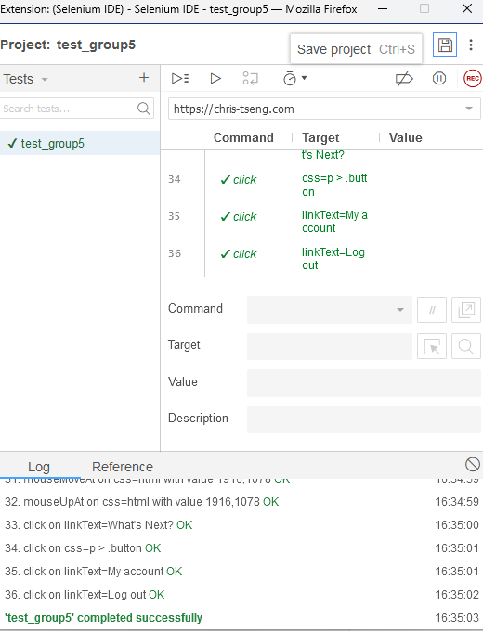

*MAC OS X 10.15.7, Mozilla FireFox Test*

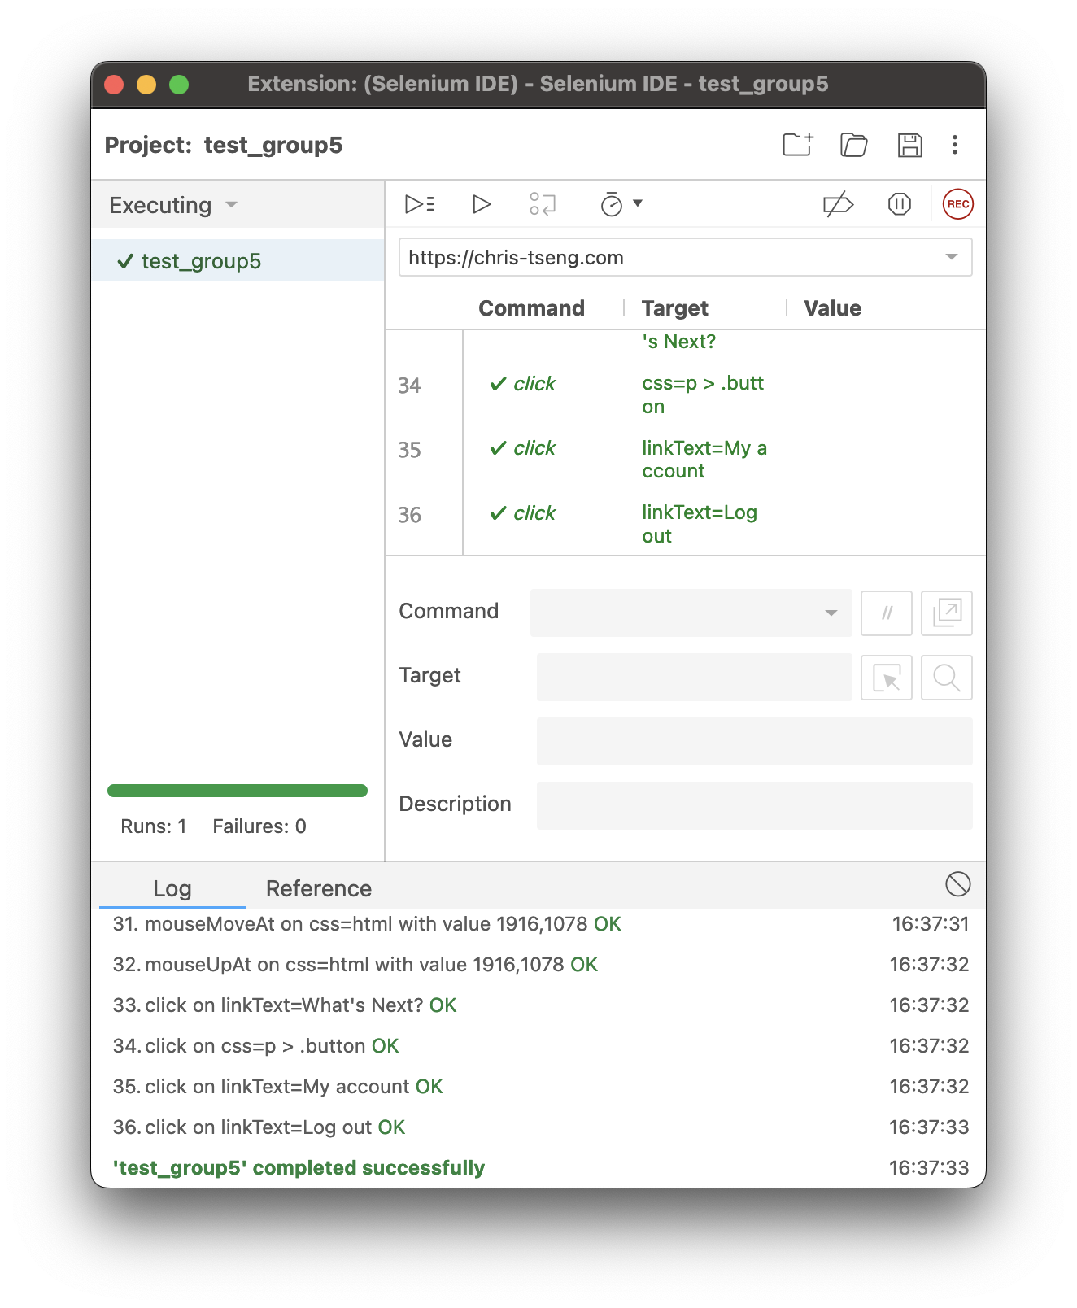

*MAC OS X 10.15.7, Google Chrome Test*

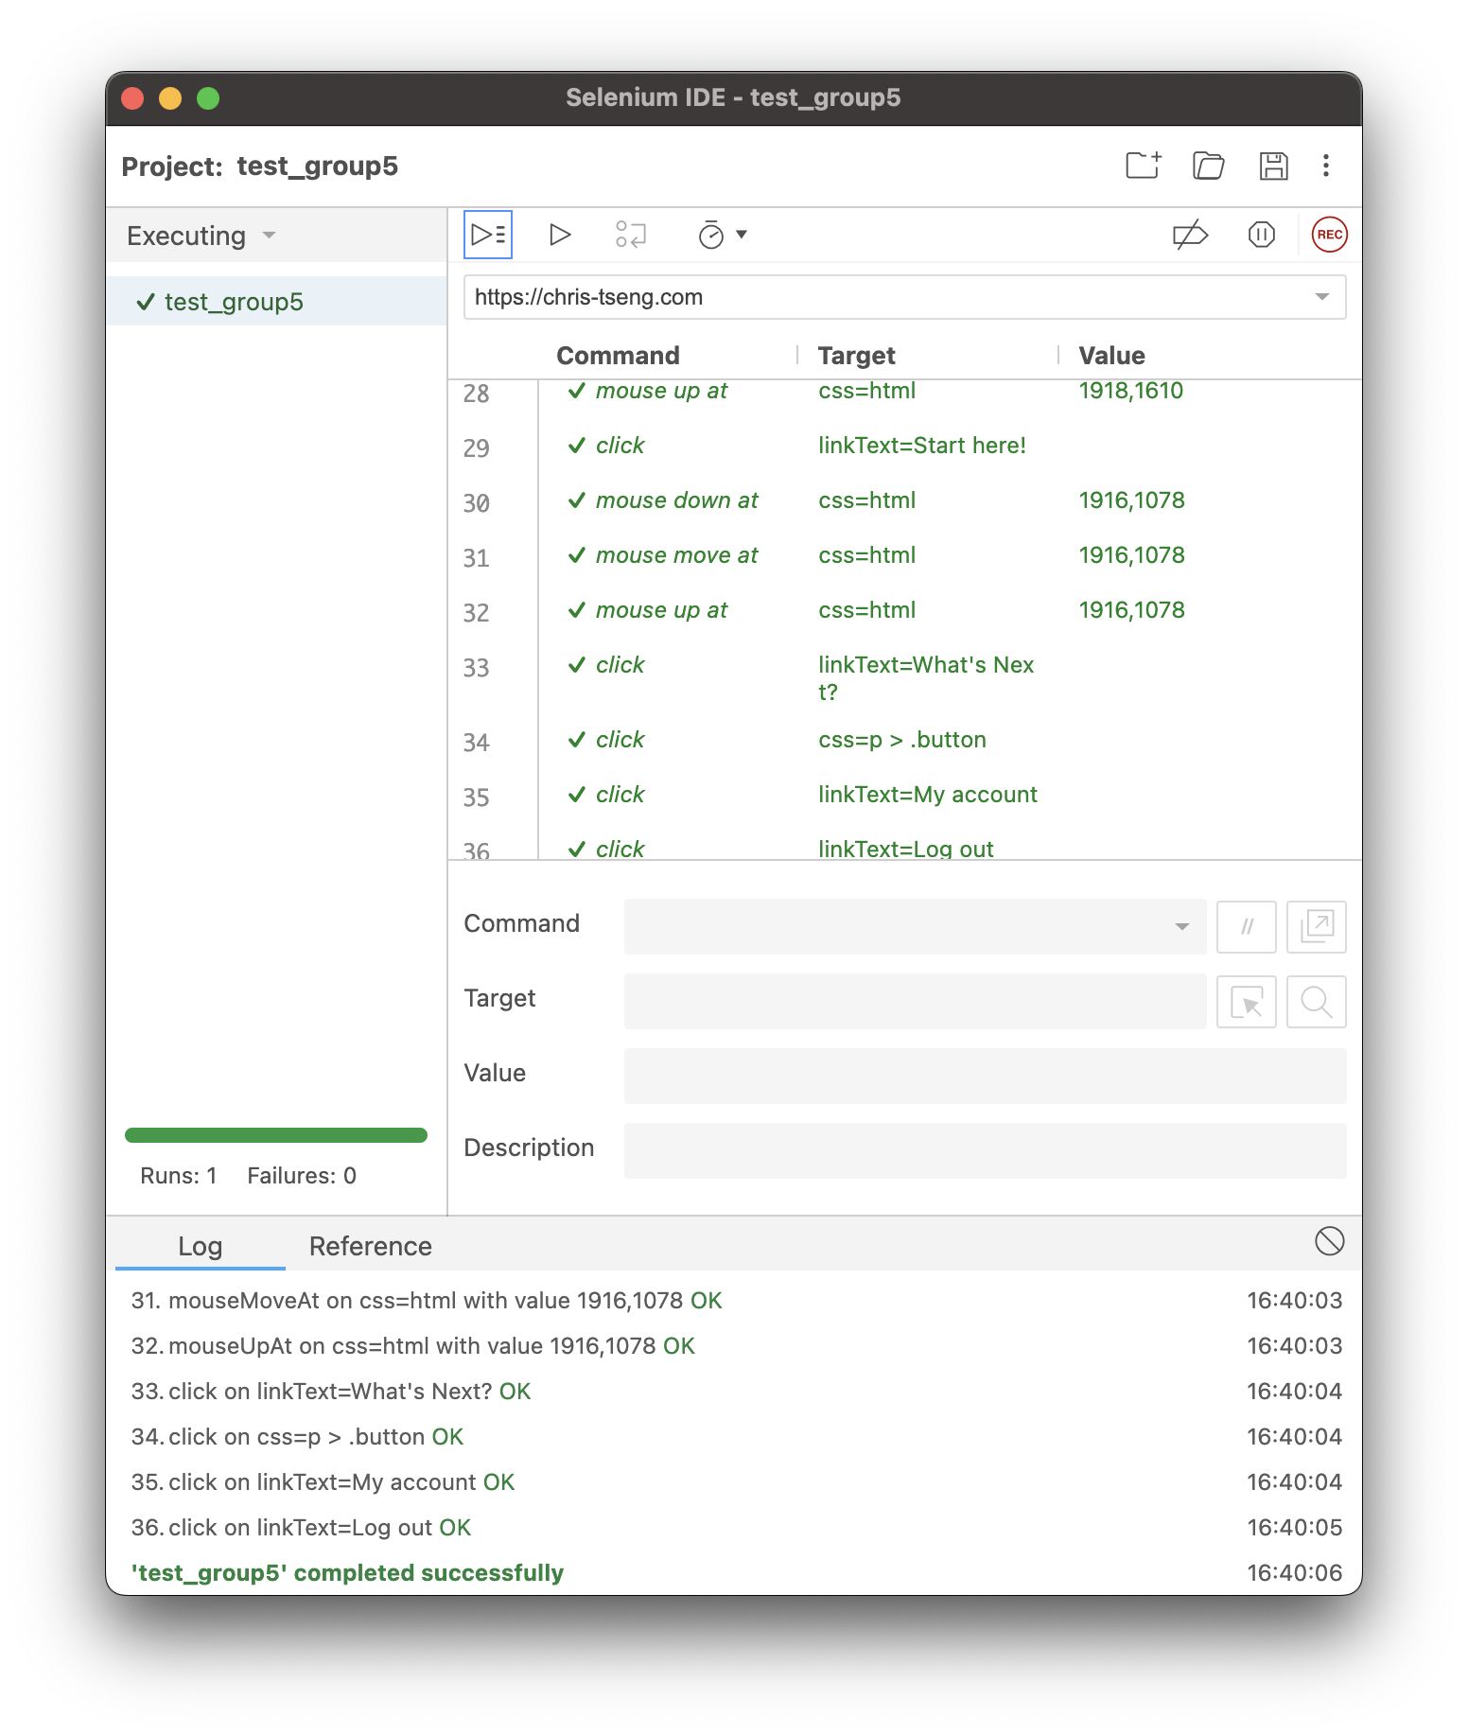

*MAC OS X 10.15.7, Safari Test*

*This test had to be modified to remove account login as the selenium side runner command line program ran too fast to let the user login load. The script also had scrollbar clicks removed as Safari did not support this.*

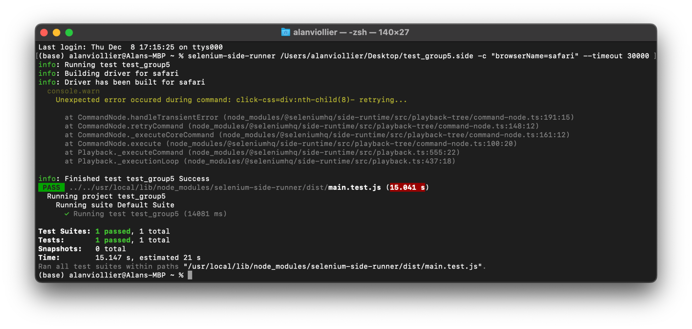

## **Testing Platform Information**

| **Client OS** | **Client Browser Versions** | **Server OS** | **Outcome** |
| --- | --- | --- | --- |
| Windows 10 | Google Chrome 15.0.874.121 m | Apache | No Issues |
| Windows 10 | Firefox 6.0.2 | No Issues |
| Mac OS X 10.15.7 | Firefox 107.0.1 | No Issues |
| Mac OS X 10.15.7 | Google Chrome Version 108.0.5359.98 | No Issues |
| Mac OS X 10.15.7 | Safari Version 16.1 (17614.2.9.1.13, 17614) | Safari Selenium rester was too fast so had to remove login Otherwise, No Issues |
| Windows 10 | Internet Explorer 8 | Browser not supported by Selenium |
| Windows 11 | Google Chrome 15.0.874.121 m | No Issues |
| Windows 11 | Firefox 6.0.2 | No Issues |

# **Typical Flow of Website with Narrated Snapshots**

## **Homepage**

When someone first visits our website, they are brought to the homepage. As we can see in the image below, the homepage contains a clear menu that has tabs to go to all four of our features. Below the menu, we can also see a welcome message letting newcomers know what the website is about and what to expect, along with an image about machine learning.

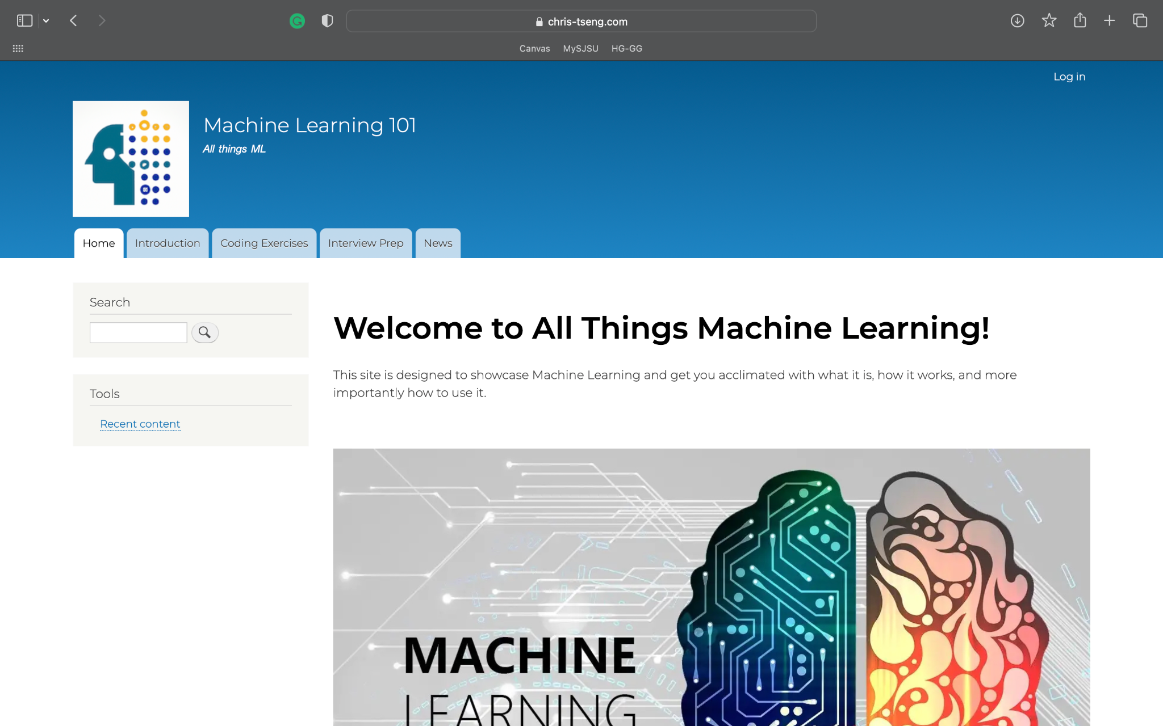

If users don’t decide to click on one of the menu tabs, they can scroll down the homepage to find small introductions to every feature on the website as seen below. Every introduction lets people know what the feature is and allows them to click on either the image or the button to go to that specific feature. These features are also in order from least experienced to most experienced, allowing new users to have a streamlined order of content. All in all, these give people a more clear understanding of the website, its features, and how to navigate it.

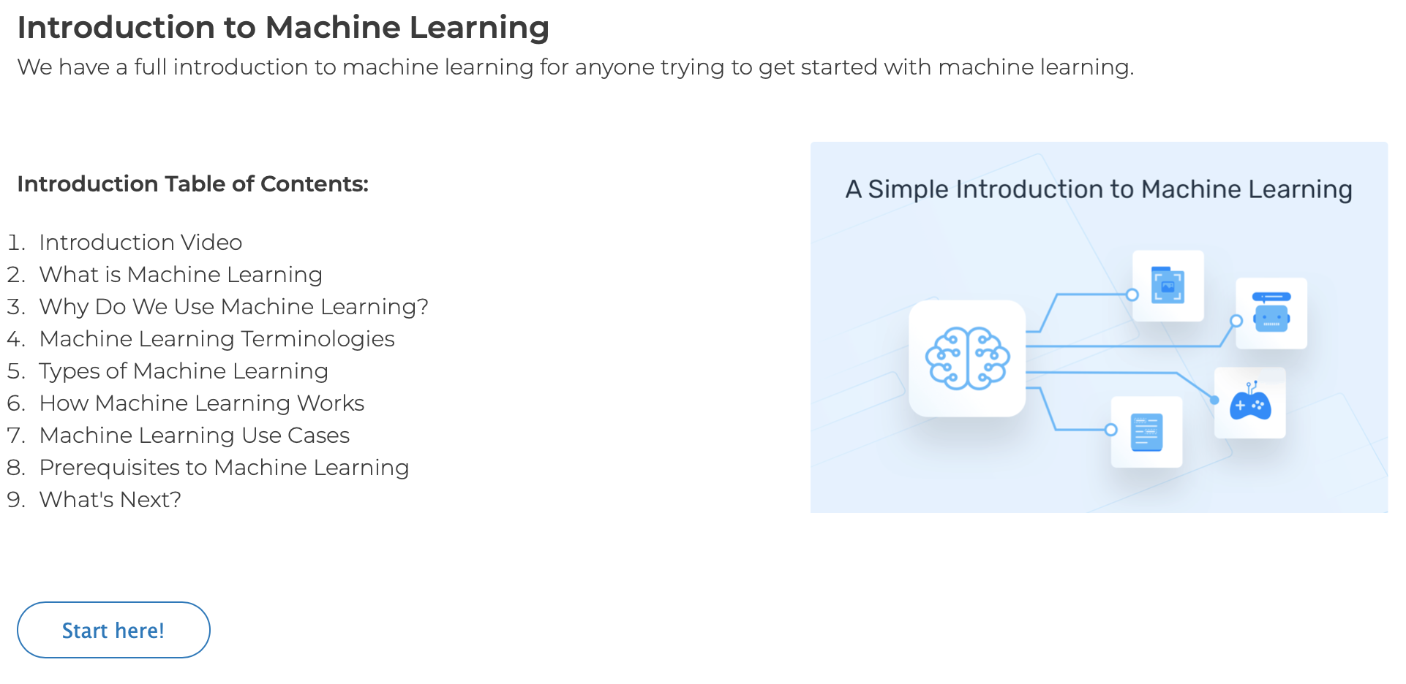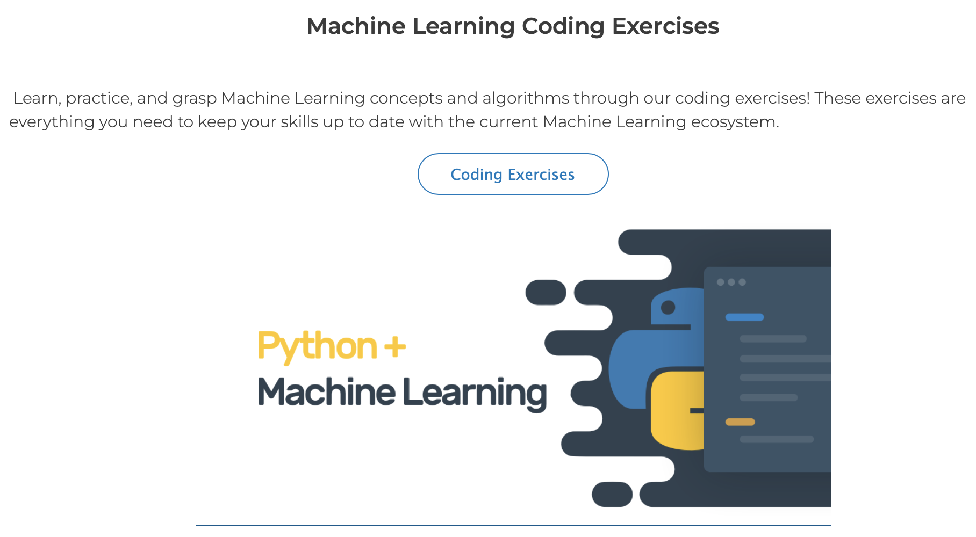

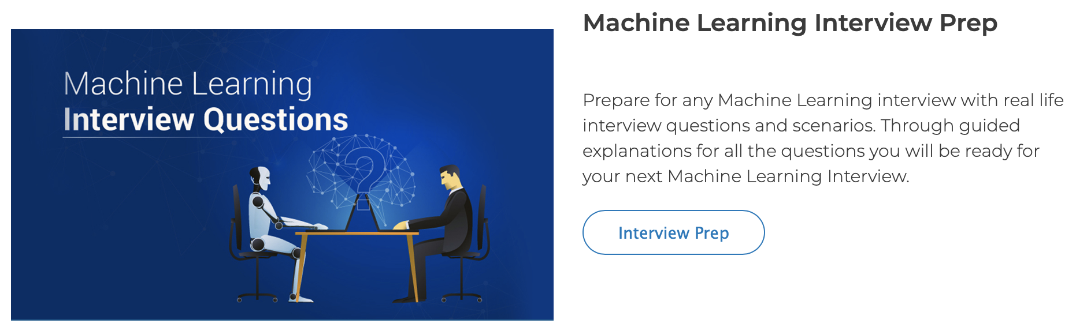

## **Introduction to Machine Learning Page**

To get to the Introduction to Machine Learning page, someone can use the menu tab from any page or use the “Start here!” button next to the introduction summary on the homepage. Once there, they will see a nice picture and the contents of the whole page with clickable links to all the different sections of the page. If people don’t use the links they can simply scroll down to see an introduction to machine learning in proper order.

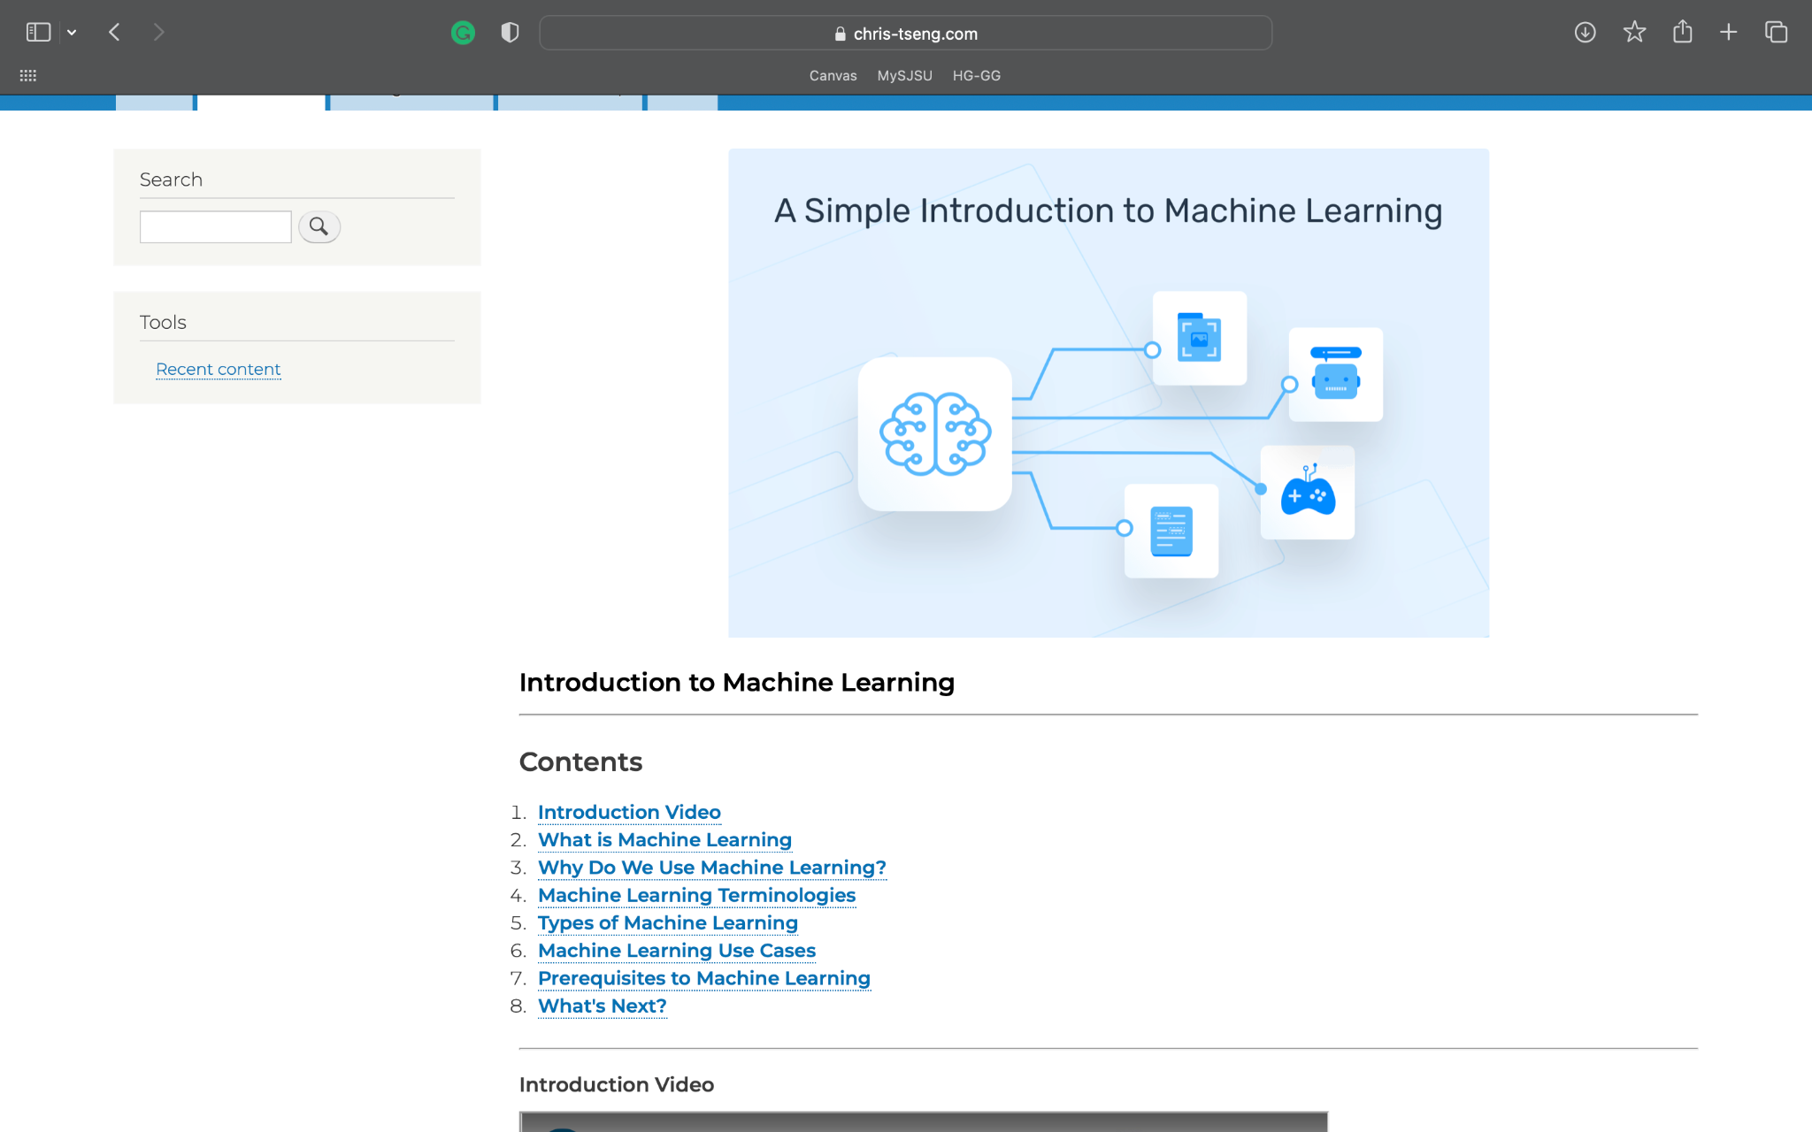

As people keep scrolling down the introduction to machine learning page they will see more content, embedded videos, and pictures that will all help them understand what machine learning is.

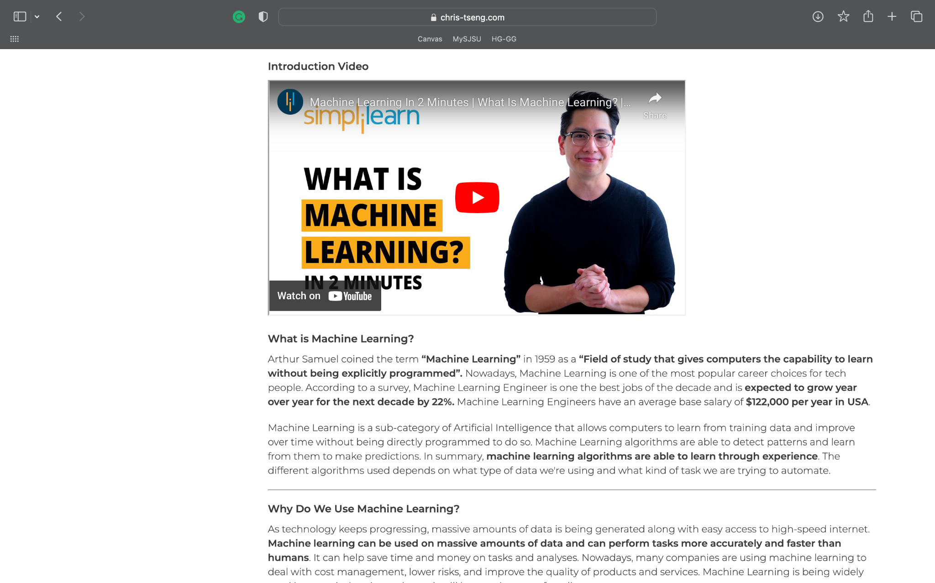

Once people get to the bottom of the introduction to machine learning page they will see a “what’s next” section. It will let them know they can learn more in-depth about the machine learning algorithms on the next page and give them a button to press to go there. This makes the flow of the website clear and in order as someone who just learned about machine learning can now go practice it.

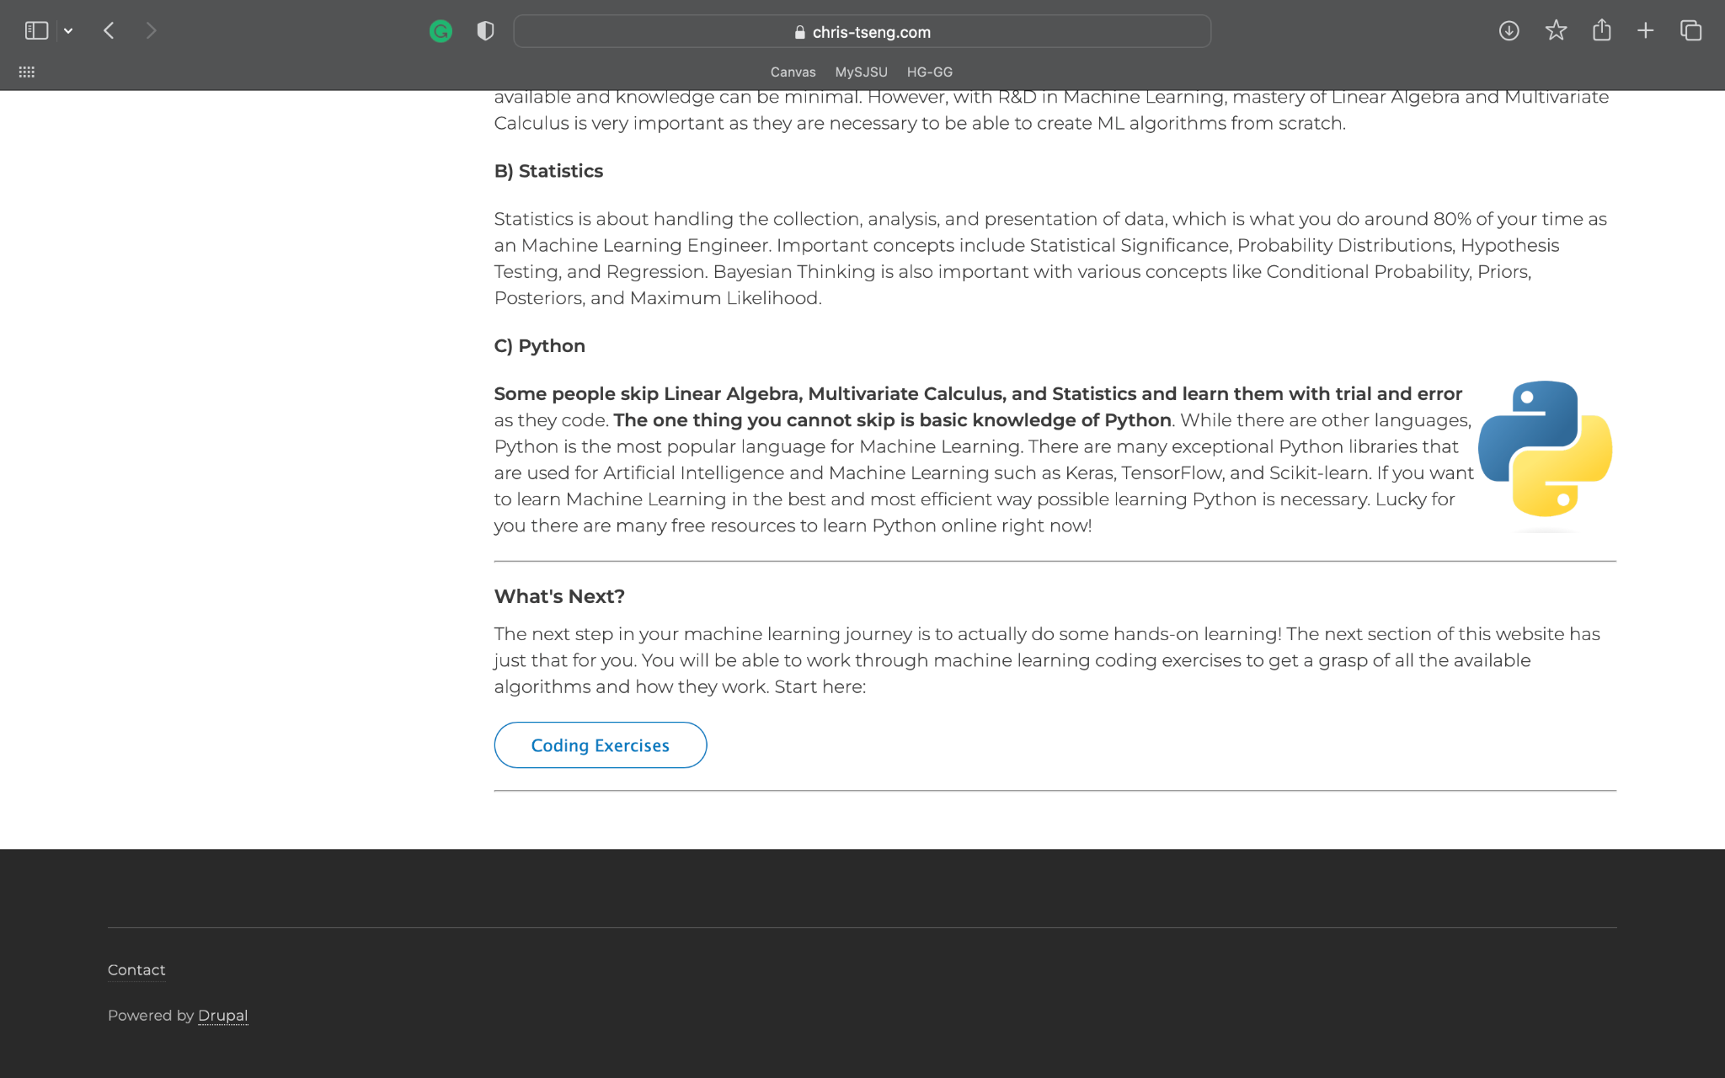

## **Machine Learning Algorithms Page**

To get to the coding exercises page, someone can use the menu tab from any page or use the “ML Algorithms” button at the bottom of the introduction page. Once there there will be an introduction to ML algorithms with links to specific algorithm pages that have coding exercises.

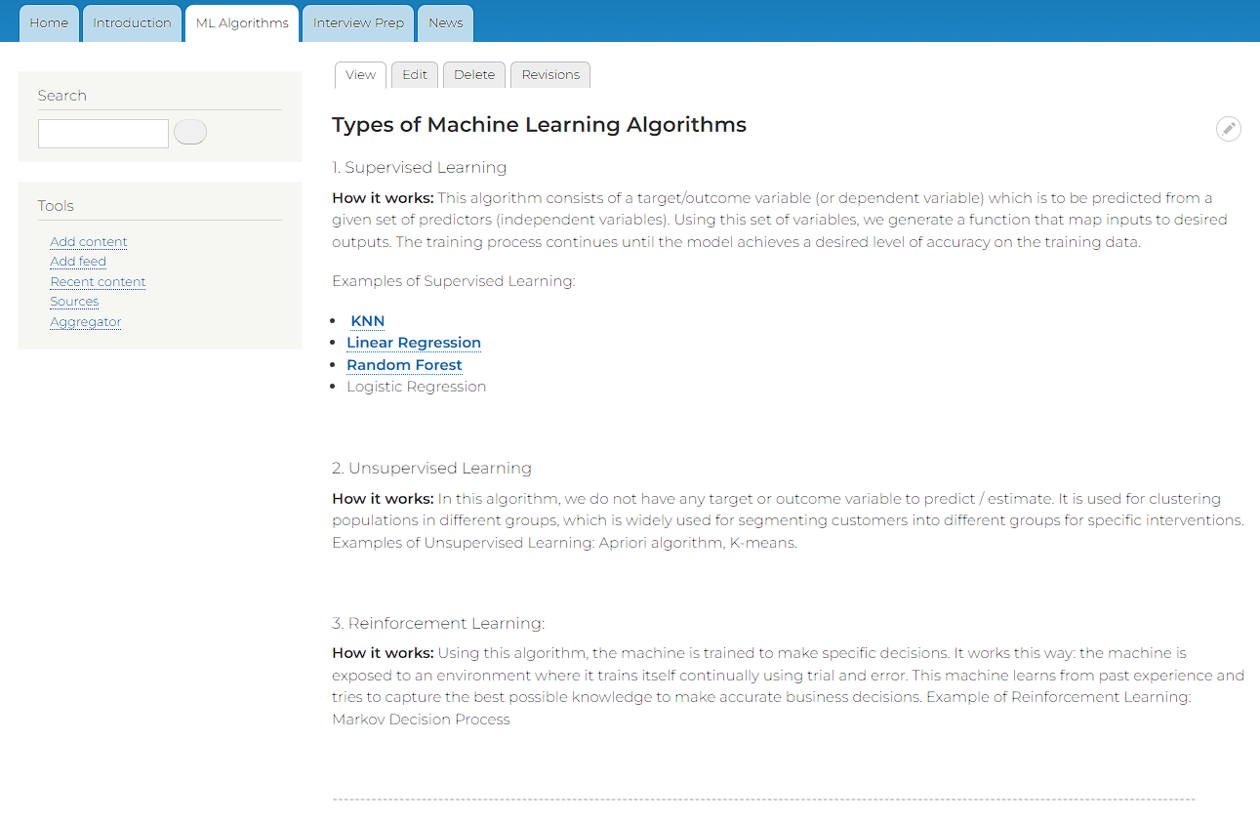

Clicking on an algorithm will prompt the user to the subpage going in depth on the algorithm along with a code walkthrough example.

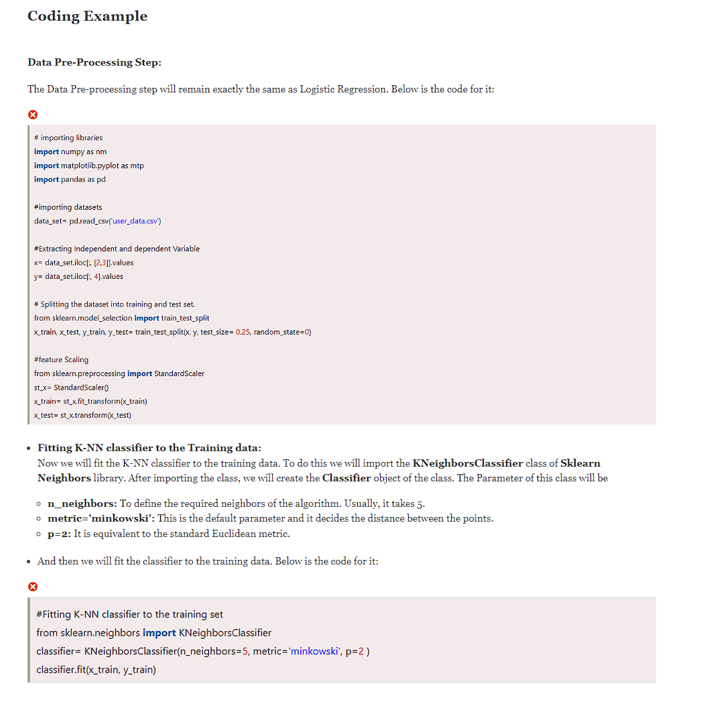

## **Machine Learning Interview Preparation**

To get to the interview preparation page, someone can use the menu tab from any page. Once there, people can read an introduction to machine learning interviews to see what this feature is about.

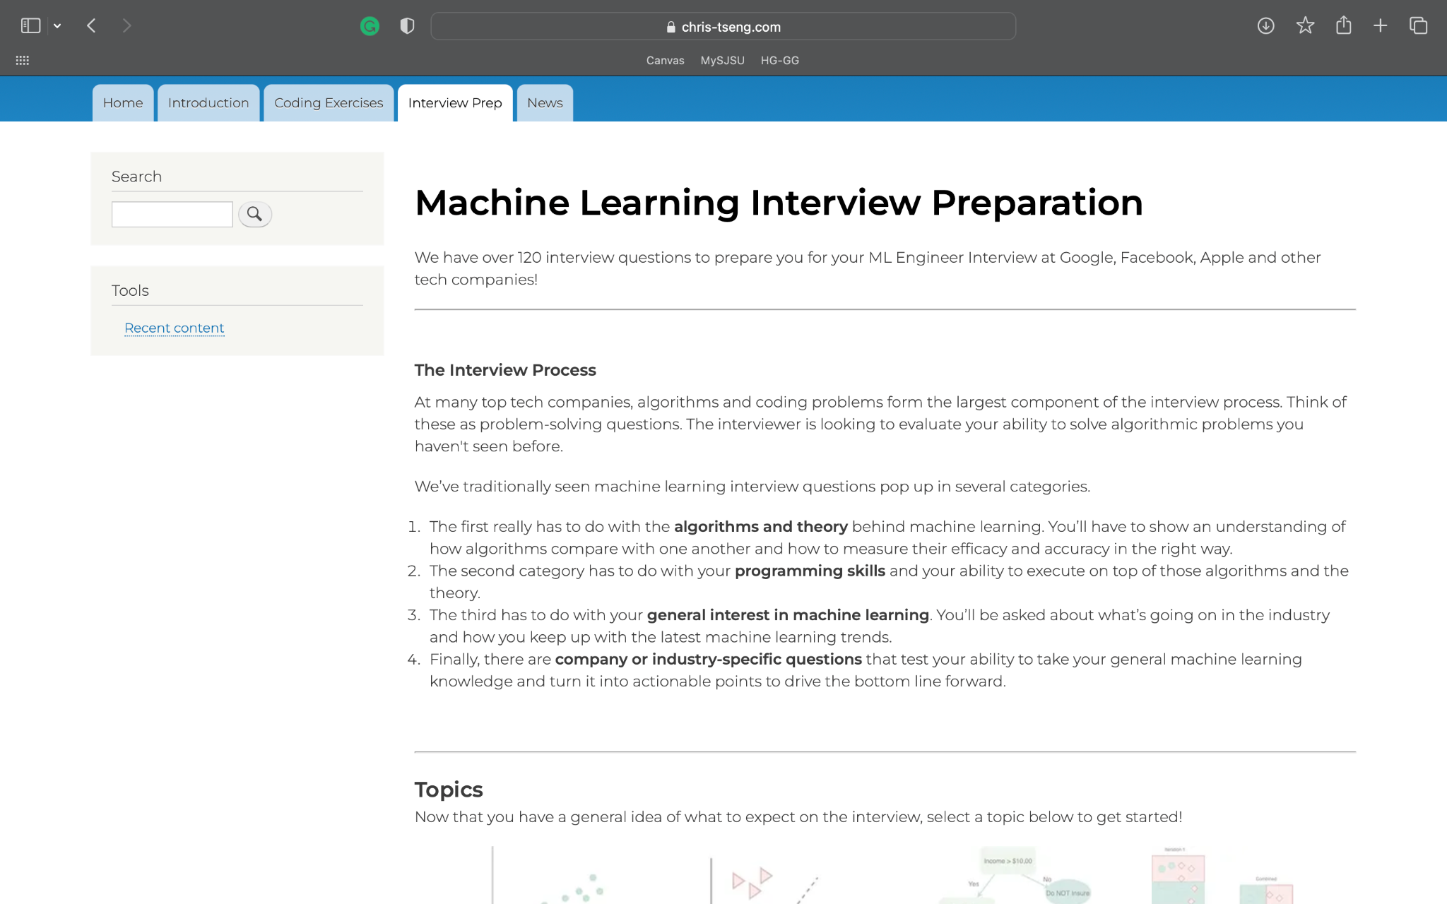

After scrolling down the page, people are presented with categorized topics with clickable links and pictures. These will bring them to interview questions for each specific topic.

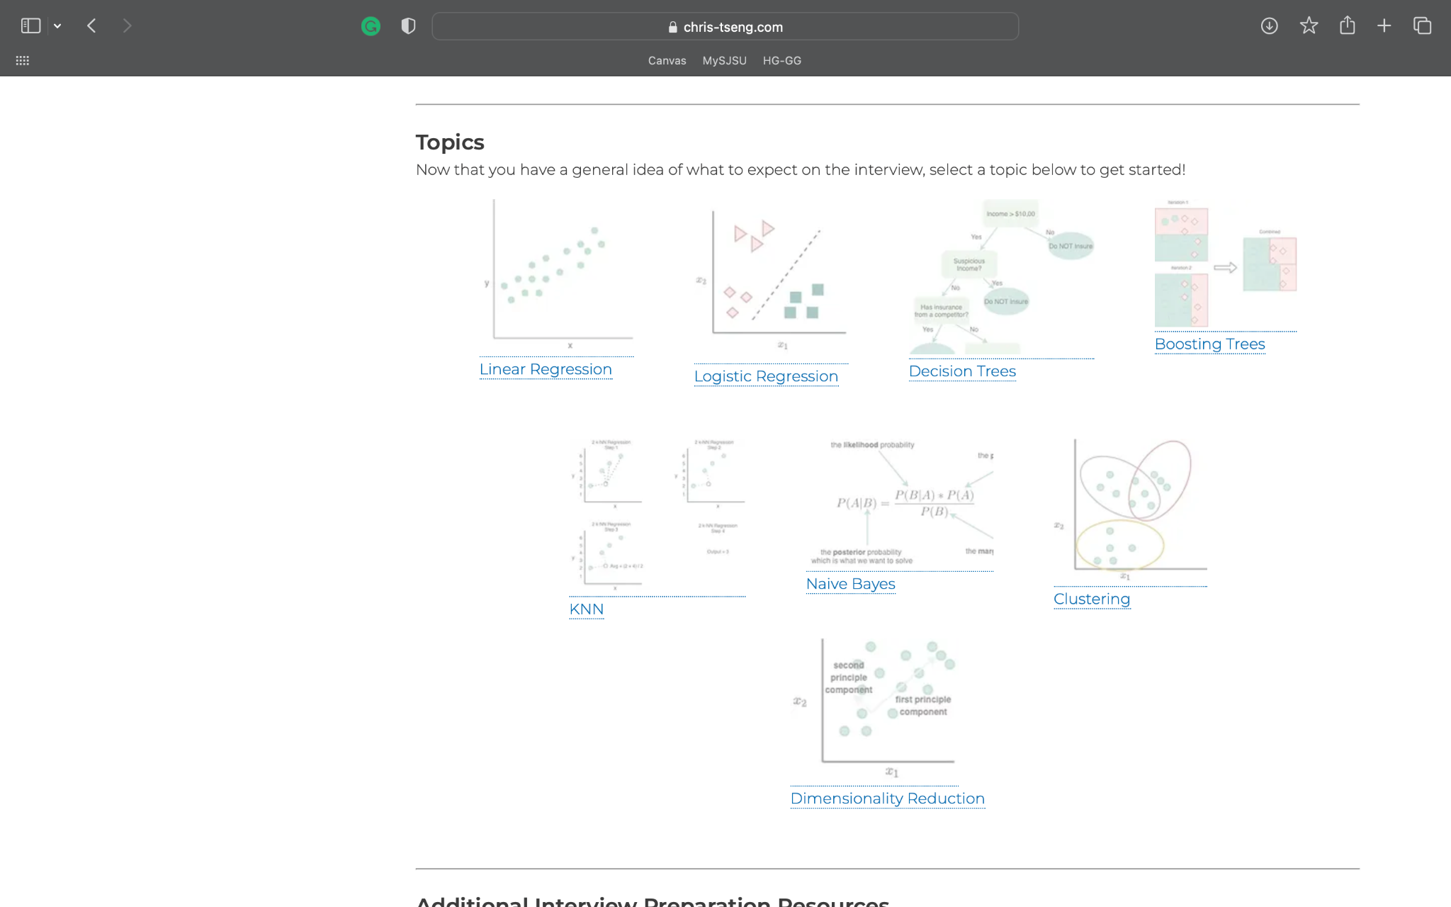

After someone clicks on a link or a picture for the topic they want to prep for they will be brought to a sub-page with questions for that topic. As we can see in the picture below people are presented with questions and as they click the buttons the answers will be revealed to them as they progress. Hiding the answer at first challenges people to try to think of the answer before they actually see it.

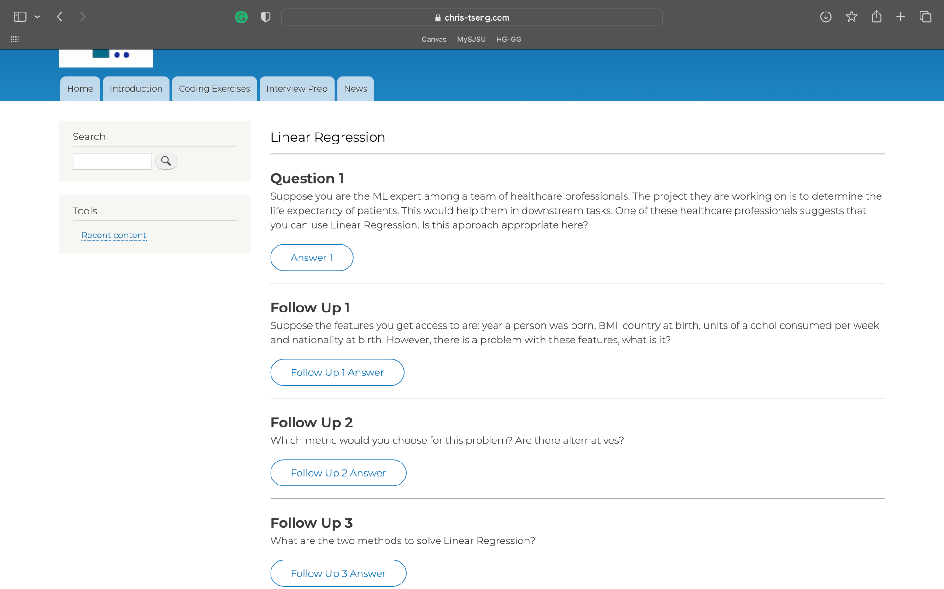

Back on the main page of the interview prep feature, there is also a link to more external resources for learning.

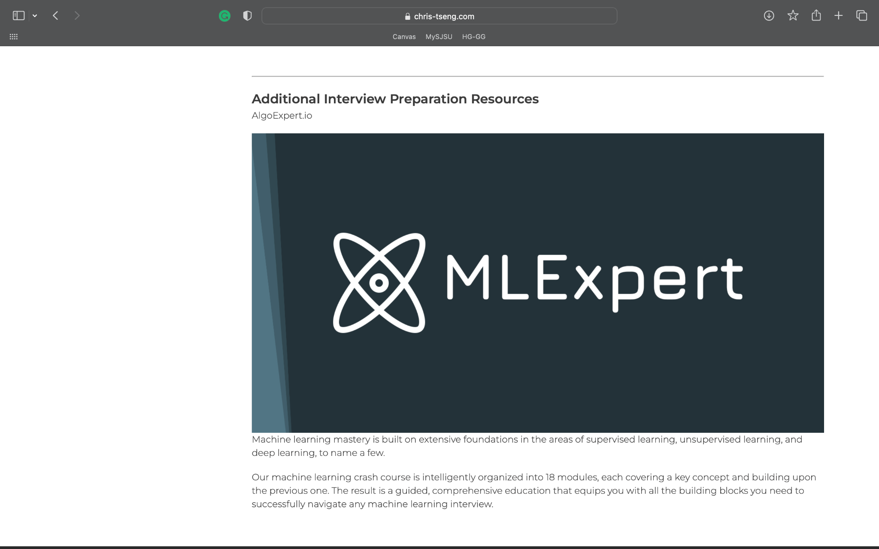

## **Machine Learning News and Trends Page**

To get to the coding exercises page, someone can use the menu tab from any page. Once there they will be presented with articles with links to subpages to those articles. As they scroll down they will see more articles and a user-only comment section for the news page. Users can feel free to comment if they like the current article selection.

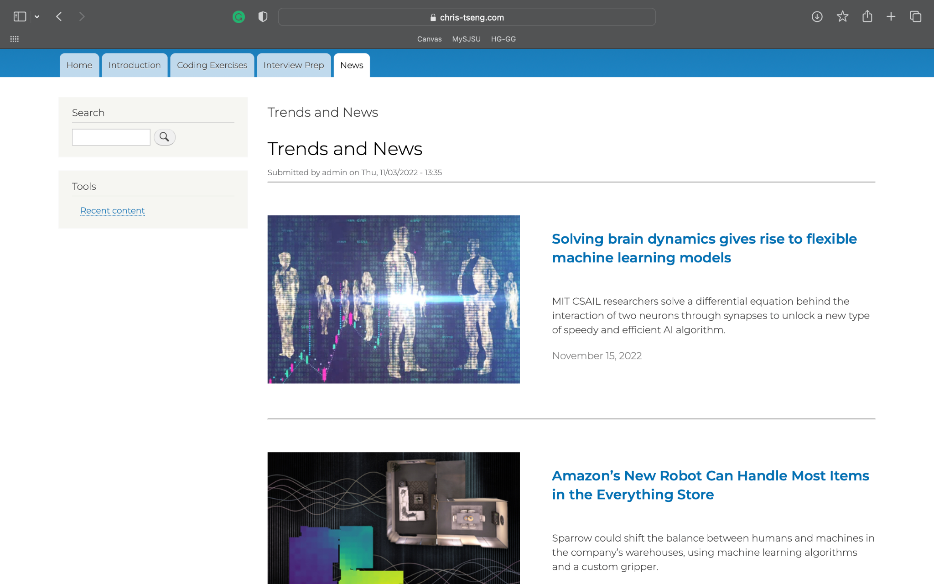

Once someone clicks on the links to get to one of the articles they will simply be presented with that news article. They can read through it and learn more about machine learning news. At the bottom of each article, there is a comment section that allows signed-in users to comment on what they think about the article.

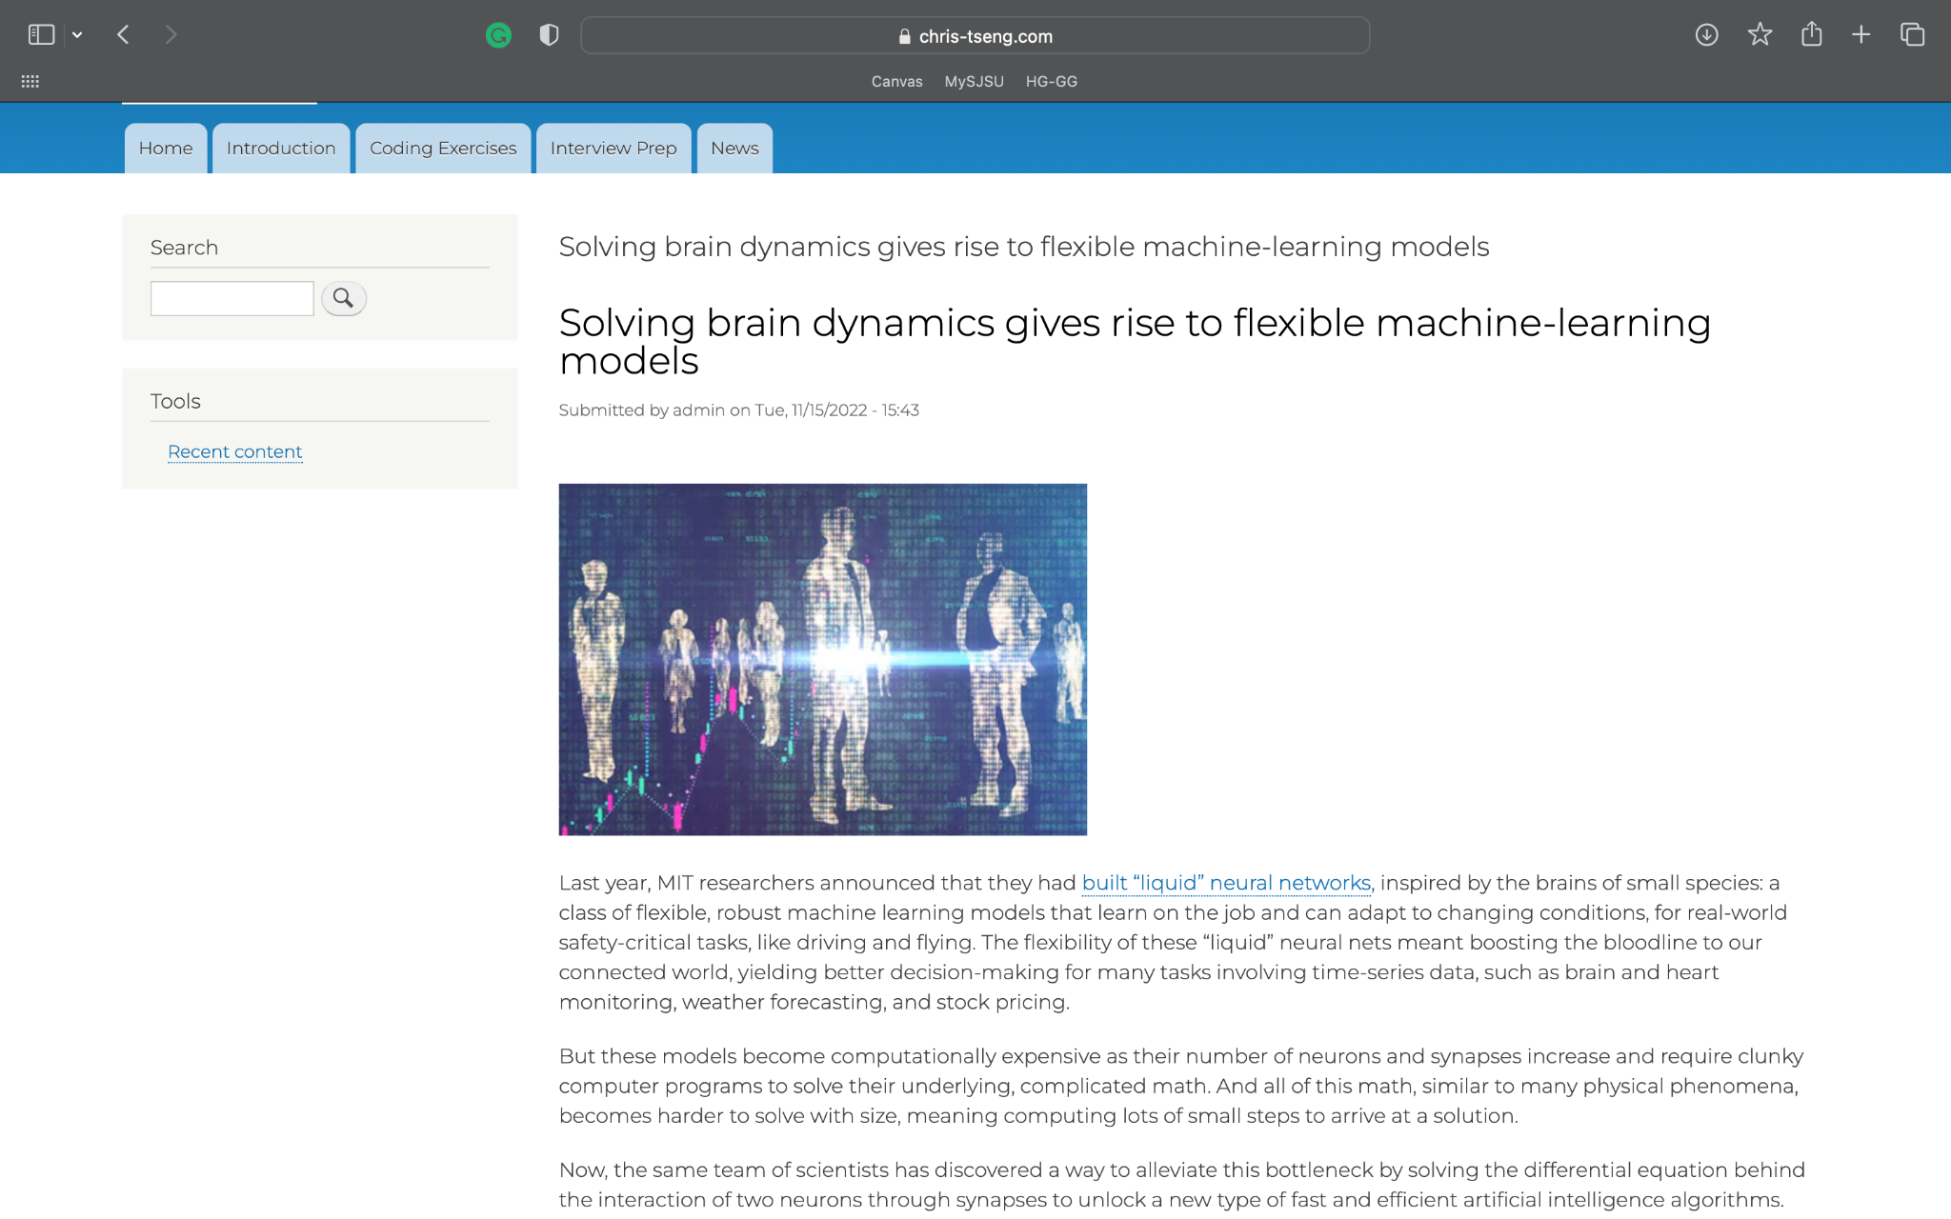

# **Version Control on Drupal**

To collaborate, the website is first uploaded onto the server. Once uploaded, each team member can make a user account or simply use the admin account to update the website. If any unwanted changes are made, the website can be rolled back through the site’s revisions tab. The revisions tab also keeps a log of all the changes made to a particular page, allowing the team to keep track of changes made. Git and git-based applications were not used to perform version control.

# **Final Specs, Use Cases, Use Case Diagram**

## **Feature #1 Intro to Machine Learning for Beginners (Core Requirement c2, c5)**

### **Introduction to Machine Learning Page**

* 1. Describe what this feature is all about
  2. The link to the Intro to Machine Learning page will be presented on the home page in a friendly manner towards the top.
  3. This Intro to Machine Learning page will have a brief history of machine learning, what machine learning is, why it’s useful, and how people use it.
  4. This page will have the latest beginner-friendly tutorials on getting started with the first steps of machine learning.
  5. Finally, the Intro to Machine Learning page will have a clear link at the bottom to the Machine Learning Algorithms with Exercises section to provide a smooth transition for beginners.

### **How it will be useful to users**

* 1. This page will allow those who have never heard of or have a vague understanding of machine learning to get a basic idea of what it is and give them a nice simplified/easy way to understand it.
  2. This will provide users with a basic road map of what there is to learn and give them a smooth transition for getting into the algorithms.
  3. Having the Intro to Machine Learning page link at the top of the home page will make it so beginners follow the path of least resistance and don’t have to motivate themselves to get lost in the website to know where to start. This is useful for beginners who might be afraid to learn a whole new concept.

### **Why this is Innovative**

An introduction to the machine learning page for beginners will allow anyone interested in machine learning to learn what it is without having to put effort to search the internet and find all the information themselves. It’ll provide a path of least resistance that’ll invite more users to use the webpage and not scare away beginners who might not have the motivation for a couple more clicks through a webpage.

Anyone who reads through this page will have a basic understanding of what machine learning is. They’ll read and watch what machine learning is, why it’s useful, and how people use it. This will allow any range of knowledge levels to get a smooth transition into using the rest of the website and all its features.

All in all, this is innovative as it allows anyone to learn what machine learning is with ease.

### **URL References**

[Codeacademy](https://www.codecademy.com/catalog/subject/machine-learning) (https://www.codecademy.com/catalog/subject/machine-learning)

[GeeksforGeeks](https://www.geeksforgeeks.org/how-to-start-learning-machine-learning/) (<https://www.geeksforgeeks.org/how-to-start-learning-machine-learning/>)

## **Feature #2 Machine Learning algorithms with coding examples/practices (Core Requirement c1-c5)**

### **ML Algorithms Page(Intro page with subpages for each algorithm)**

1. Display intro to what algorithms in Ml are and what their purpose is.
2. Categorized concepts of Machine Learning with links to each individual algorithms
3. Each algorithm has its own page with a description of the algorithm, along with copyable code to show it in a use case
4. Advantages and disadvantages to each algorithm
5. Parameters and optimization to fine-tune the performance of algorithms depending on data

### **How it will be useful to users**

1. Allows users to gain a deeper understanding of the concepts
2. Gives hands-on practice for implementation
3. Users will learn when and why to use certain implementations.
4. In-depth descriptions that help users learn skills required for their own projects

### **Why this is Innovative**

This is a form of accelerated learning where the user can get a description of what algorithm they are using, its benefits, and when to use them Allows for both beginners and professionals to learn some useful skills that will help improve their performance in their own applications, or just allow them to have a much deeper understanding of the concepts in a digestible manner.

### **URL References**

javaTpoint(<https://www.javatpoint.com/simple-linear-regression-in-machine-learning>)

## **Feature #3 Machine Learning Interview Preparation (Core Requirements C1, C3, C5)**

### **Machine Learning Interview Prep Page**

1. The ML Interview Prep module will be displayed near the top of the website for users to click on.
2. From there, users will be presented with a categorized list of Machine Learning topics which they can click on to see the interview questions on it. These questions will be common interview questions asked by top tech companies during interviews, so users can be sure that they are getting the preparation they need.
3. There will be follow-up questions that build on the original questions. Users may click on the hints if they get stuck on a problem.
4. Detailed answers to these questions will appear at the bottom of the page. It will describe different approaches to the problem as well as different solutions.
5. For coding questions, users will be given restraints to the questions and will also need to consider the time and space complexity for their algorithms.

### **How it will be useful to users**

1. This page will be useful for beginners or professionals who want to prepare for their ML engineering interviews.
2. Users will be able to apply the knowledge that they learned from the introduction to ML and the ML coding exercises to real company interview questions.
3. Users will not only have to solve the questions, but they will be asked to solve it in the most efficient, simplest way possible. They will have to know every detail about the algorithms they write.
4. Users can look up a specific topic they want to practice on, for example, if they want to know interview questions about Linear Regression or Neural Network.

### **Why this is Innovative**

These questions will go beyond basic, introductory ML questions and require users to apply the knowledge to real life questions.

If users get stuck, they will be given hints, much like in a real interview, you can ask questions from the interviewer. The fewer hints the users require, the better they know the material.

If users are not able to solve the questions, they can look at the solutions. Links to the material will also be provided so users can review the subject.

### **URL References**

[Machine Learning Engineering Interviews](https://www.mle-interviews.com/) (https://www.mle-interviews.com/)

## **Feature #4 Machine Learning Trends and News (Core Requirement c1 & c3-c5)**

### **News And Trending Page**

1. This feature will contain collections of news articles related to machine learning.
2. The user does not need an account to access this feature.

### **How it will be useful to users**

1. Users will be able to keep up to date with current trends and news about machine learning.
2. Users will be able to look up topics of interest

### **Why this is Innovative**

A simple web page containing highlights of news and trends is a good way to have a collection of information about machine learning and the applications of it in the current time. People who know little to nothing about machine learning can find interesting articles that may motivate them into learning more about the topic. On the other hand, machine learning professionals and experts can stay up to date with the current trends and news, giving them the idea of which topic is currently “hot.” Furthermore, users do not need to dive deep to find the latest news and trends since articles that cover trending topics will be displayed front and center.

### **URL References**

[12 Features Of A Great Site Search Function | SilverDisc Digital Marketing Agency](https://www.silverdisc.co.uk/blog/2016/02/19/12-features-great-site-search-function) (<https://www.silverdisc.co.uk/blog/2016/02/19/12-features-great-site-search-function>)

## Use Cases

| Use Case ID | F1-1 |
| --- | --- |
| Use Case Name | Completely new beginner visits the website looking for the basics of machine learning |
| Created By | Alan Viollier |
| Actor | User |
| Description and Event Flow | The user arrives at the home page of the website.   1. The user sees a friendly/inviting link of machine learning introduction for beginners without having to scroll down. 2. The user clicks on the introduction for beginners link. 3. The user arrives at the introduction to machine learning for beginners page. 4. The user scrolls down to see what machine learning is, why people use it, and how people use it nowadays. 5. The user finds an embedded youtube video of the latest introduction to machine learning. 6. The user clicks the embedded video, watches it, and learns the basics of machine learning. |
| Pre-conditions | * The user is connected to the internet * The user’s firewall and security options are not blocking the website * The website’s server is up and running * The user is on the website’s home page |
| Post-conditions | * The intro to machine learning page is successfully loaded and all scripts are functional |
| Input | * Mouse clicks |
| Output | - The websites home page and intro to machine learning for beginners page  - The imbedded youtube video loads |
| Includes |  |
| Notes |  |

| Use Case ID | F2-1 |
| --- | --- |
| Use Case Name | ML algorithm description and implementation |
| Created By | Harin Avvari |
| Actor | User |
| Description and Event Flow | A user clicks onto the ml algorithms and implementation page   1. The user can scroll to read the intro page talking about the role of algorithms and its surrounding concepts 2. User can then scroll further to see links to each type of algorithm 3. Each algorithms page has its description at the top, pros con, etc 4. Scrolling down further that the description shows code snippets with brief description underneath 5. Then shows user optimization features, again showing code between an algorithm with random parameters and its output vs optimized parameters and output. |
| Pre-conditions | * The user is connected on the internet * The user’s firewall and security options are not blocking the website * The website’s server is up and running * The user has navigated to and is on the ML Algorithms page |
| Post-conditions | * The pages are correctly loaded, and show the code snippets |
| Input | Mouse click |
| Output | -ML algorithms home page  -Each algorithm sub page  -output from code snippets on each page |
| Includes |  |
| Notes |  |

| Use Case ID | F3-1 |
| --- | --- |
| Use Case Name | User wants to practice interview coding questions |
| Created By | Angela Yang |
| Actor | User |
| Description and Event Flow | A user clicks on the interview preparation module and is looking for ML interview preparation questions:   1. User clicks on the interview module and is given an option to prepare for ML coding questions or ML Short Answer questions. 2. User clicks on the coding questions link and is shown several algorithms to be tested on. 3. Once users click an algorithm, they are shown a list of questions related to the algorithm. They are ranked based on difficulty. 4. The user clicks on the question. The question is displayed, along with any special restraints (input restrictions, etc). 5. Users will be asked to compute the time and space complexity of their algorithm, but they will not be checked on their answers. 6. If the user gets stuck and cannot proceed, they can click on the hints tab. 7. If the users still cannot solve the question, or if they want to compare their answers to the solution, they can review the answers at the bottom. 8. Depending on the question, there might be several approaches and they will be listed. |
| Pre-conditions | * The user is connected to the internet * The user’s firewall and security options are not blocking the website * The website’s server is up and running * The user is on the website’s home page |
| Post-conditions | -Employer’s account is created in CSNet  -Employer can login to their account |
| Input | -Mouse Clicks |
| Output | -Interview Preparation Page  - Interview Question, Hints and Answers |
| Includes |  |
| Notes | -Questions that the user solves will be tracked. |

| Use Case ID | F4-1 |
| --- | --- |
| Use Case Name | Search for a Specific Article |
| Created By | Jonathan Nguyen |
| Actor | User |
| Description and Event Flow | The user arrives on any page on the website   1. The search bar is initially empty. It is a text field that accepts any UTF-8 character. 2. The user enters any valid string, strings, or chooses to leave the text field empty 3. The user clicks on “Search” button to search for related articles found throughout the website 4. Results will be displayed based on the user’s search terms |
| Pre-conditions | * The user is connected to the internet * The user’s firewall and security options are not blocking the website * The website’s server is up and running * The user is on the website’s news page |
| Post-conditions | * The web page is successfully loaded and all scripts are functional |
| Input | Required:  -An empty string, string of characters, or multiple strings must be entered in the search bar |
| Output | - Website’s header and footer are still displayed in the usual spots  - Page results will be returned based on the string(s) entered in the search bar. If no results are returned, let the user know that there were no results  - Each result has its own heading or title, which is also a clickable hyperlink used to access that article  - A short segment of the article will accompany the heading or title |
| Includes |  |
| Notes | -Upon a successful or failed search, do not reset the search terms and settings |

## Use Case Diagram

~~

 